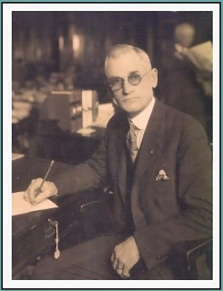

Thelma Carden’s Dress

Senator William Carden
August 24, 1865 – March 18, 1950

Served the State Legislature Six Years
Served in the Senate Eight Years

